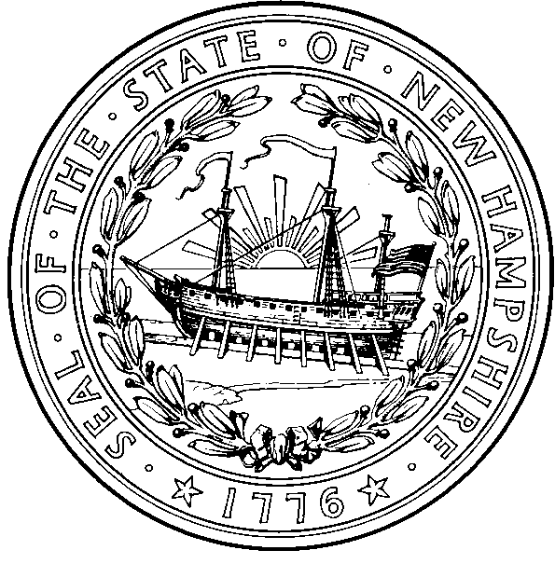  Nicholas A. Toumpas  Commissioner  Jose’ Thier Montero  Director | STATE OF NEW HAMPSHIRE  DEPARTMENT OF HEALTH AND HUMAN SERVICES  29 HAZEN DRIVE, CONCORD, NH 03301-6527  603-271-4482 1-800-852-3345 Ext. 4482  Fax: 603-271-3850 TDD Access: 1-800-735-2964 www.dhhs.nh.gov

New Hampshire

School Immunization Requirements 2011/2012

- Children must have proof of all required immunizations, or valid exemptions, in order to attend the first day of school. Documentation of immunity by confirming laboratory test results is acceptable.
- A child may be enrolled under conditional enrollment when the parent or guardian provides: (1) Documentation of at least one dose for each required vaccine; and (2) The appointment date for the next due dose of required vaccine. (He-P 300.13) http://www.gencourt.state.nh.us/rules/state_agencies/he-p300.html
- Look at the Minimum Age and Interval Table on page 2 for recommended minimum age and spacing information. All vaccine immunizations must meet minimum intervals and age requirements for that vaccine; a 4-day grace period is acceptable.
Medical and religious exemption information is available at: http://www.dhhs.nh.gov/dphs/immunization/exemptions.htm
Varicella | K-2nd  2 Doses1 | 3rd Grade  2 Doses² | 4th – 5th Grade  1 Dose² | 6th – 8th Grade  2 Doses² | 9th – 12thGrade  1 Dose²
DTaP  DT/DTP  Td/Tdap | 6 years and under: 4 or 5 doses, with the last dose given on or after the 4th birthday.  7 years and older: 3 or 4 doses, with the last dose given on or after the 4th birthday.  11 years and older: a one time dose of Tdap when more than 5 years have passed since the last tetanus toxoid containing vaccine;3 then boost with Td every 10 years. If a child turns 11 on or after the first day of school, they are required to have Tdap prior to first day of the next school year.
Polio | Grades K-12: 3 doses, with the last dose given on or after the 4th birthday.4  Or 4 doses regardless of age at administration.4,5
MMR | Grades K-12: 2 doses required, at least one on or after the first birthday
Hepatitis B | Grades K-12: 3 Doses at acceptable intervals
January 2011 Page 1 of 2

New Hampshire School Immunization Requirements 2011/2012

Minimum Age & Interval for Valid Vaccine Doses
Vaccine | Dose # | Minimum Age | Minimum Interval Between Doses | Notes
Hepatitis B  HepB | HepB – Dose 1 | Birth | 4 weeks between Dose 1 & 2 | Minimum age for Dose 3 is >24 weeks.
Hepatitis B  HepB | HepB – Dose 2 | 4 weeks | 8 weeks between Dose 2 & 3 | Minimum age for Dose 3 is >24 weeks.
Hepatitis B  HepB | HepB – Dose 3 | 24 weeks | 16 weeks between Dose 1 & 3 | Minimum age for Dose 3 is >24 weeks.
Diphtheria, Tetanus, and Pertussis  DTAP/DT | DTaP – Dose 1 | 6 weeks | 4 weeks between Dose 1 & 2 | The fifth dose is not necessary if the fourth dose was administered at age 4 years or older.
Diphtheria, Tetanus, and Pertussis  DTAP/DT | DTaP – Dose 2 | 10 weeks | 4 weeks between Dose 2 & 3
Diphtheria, Tetanus, and Pertussis  DTAP/DT | DTaP – Dose 3 | 14 weeks | 6 months between Dose 3 & 4
Diphtheria, Tetanus, and Pertussis  DTAP/DT | DTaP – Dose 4 | 1 year | 6 months between Dose 4 & 5
Diphtheria, Tetanus, and Pertussis  DTAP/DT | DTaP – Dose 5 | 4 years | ------------------
Polio  IPV | IPV – Dose 1 | 6 weeks | 4 weeks between Dose 1 & 2 | If Dose 3 is given >4th birthday, only 3 doses are required (if an all OPV or all IPV schedule)  Advisory Committee on Immunization Practices (ACIP) recommends that the final dose in the IPV series should be administered at 4 years of age or older, regardless of the number of previous doses, and that the minimum interval between dose 3 and dose 4 be extended from 4 weeks to 6 months. This is not required for the 2011/2012 school year but will be required for incoming Kindergarteners for the 2012/2013 school year.
Polio  IPV | IPV – Dose 2 | 10 weeks | 4 weeks between Dose 2 & 3
Polio  IPV | IPV – Dose 3 | 14 weeks | 4 weeks to 6 months between  Dose 3 & 4
Measles, Mumps, and Rubella  MMR | MMR – Dose 1 | 12 months | 4 weeks between Dose 1 & 2 | If MMR, VAR, and nasal influenza vaccine are not given on the same day, they must be separated by at least 28 days.
Measles, Mumps, and Rubella  MMR | MMR – Dose 2 | 13 months | -----------------
Varicella (chickenpox)  VAR | VAR – Dose 1 | 12 months | 3 months between Dose 1 & 2 | If MMR, VAR, and nasal influenza vaccine are not given on the same day, they must be separated by at least 28 days.  If Dose 2 was given >28 days after Dose 1, it is valid.  If first dose administered ≥ age 13 years, two doses separated by a minimum interval of 4 weeks.
Varicella (chickenpox)  VAR | VAR – Dose 2 | 15 months | ------------------
Tetanus, Diphtheria, and Pertussis | Tdap – Dose 1 | 10 years |  | If a child turns 11 during the school year they are required to have Tdap by the first day of the next school year.

Page 2 of 4 January 2011

Immunization Requirements

Preschool Students 3-5 Years Old

Please refer to the Immunization Requirements School Year 2011/2012

for acceptable intervals and age requirements

DTaP/DTP/DT
3-5 years | Four doses - the third and fourth dose should be separated by at least 6 months.

POLIO
3-5 years | Three doses

MEASLES, MUMPS, and RUBELLA (MMR)
3-5 years | One dose on or after age 12 months.

HAEMOPHILUS INFLUENZAE TYPE B (HIB)
3-5 years | One dose after 15 months of age or  Four dose series with the last dose being administered  at > 12 months of age.  If the products PedVax HIB or Comvax have been used,  3 doses with one after 12 months of age is acceptable.  HIB is not required for children > 5 years of age.

HEPATITIS B VACCINE
3-5 years | Three doses given at acceptable intervals.

VARICELLA (CHICKEN POX) VACCINE
3-5 years | One dose administered on or after age 12 months.  Documentation of immunity by confirming laboratory test results is required for incoming kindergarten students if child has not received varicella vaccine. *Report new suspected cases of varicella to: DHHS, Communicable Disease @271-4496.

The 4-day grace period for minimum intervals and ages applies to the above requirements.

School Immunization Requirements, School Year 2011/2012
NH DHHS, Division of Public Health Services
NH Immunization Program
January 2011
Page 3 of 4 January 2011

Brand Names for Vaccines

The following list may be used by school nurses to connect brand names to vaccine types. The products that are crossed out are not provided through the New Hampshire Immunization Program. They are available in other states and countries.

Diphtheria, Tetanus, acellular Pertussis, (DTaP/ DT/DTP):
Infanrix®, Pediarix®, DT, Tetramune®, Daptacel®, Pentacel®

Diphtheria, Tetanus, acellular Pertussis and Polio (DTaP-IPV)
Kinrix

Tetanus diphtheria, acellular pertussis (Tdap)
BOOSTRIX® (Manufacturer: GlaxoSmithKline. May 3, 2005: approved for persons 10 through 64 years of age)
ADACEL® (Manufacturer: Sanofi Pasteur. June 10, 2005: approved for persons 11 through 64 years of age)

Haemophilus Influenzae Type B, (HIB):
ActHIB®, PedvaxHIB®, COMVAX®, Pentacel®, Hiberix®

Hepatitis B (HepB):
ENGERIX B®, Pediarix®, RECOMBIVAX®, or COMVAX®

Measles, Mumps, Rubella, (MMR):
MMRII

Measles, Mumps, Rubella and Varicella
ProQuad®

Polio, (IPV/OPV):
IPOL or Pediarix®, Pentacel®

Varicella (Chicken Pox, VAR):
Varivax®

Page 4 of 4 January 2011

1 Varicella vaccination or laboratory diagnosis of chicken pox disease required. ² Varicella vaccination or history of chicken pox disease. 3 If the child has a medical contraindication to pertussis vaccine, the child shall receive Tetanus diphtheria toxoid (Td) vaccine. 4 If a combined IPV/OPV schedule was used, 4 doses are always required, even if the 3rd dose was administered after the 4th birthday. 5 Beginning 2012/2013 school year, incoming Kindergarteners will require the last two doses of polio vaccine to be separated by 6 months, and 1 dose after age 4 years. Page 1 of 4 January 2011

