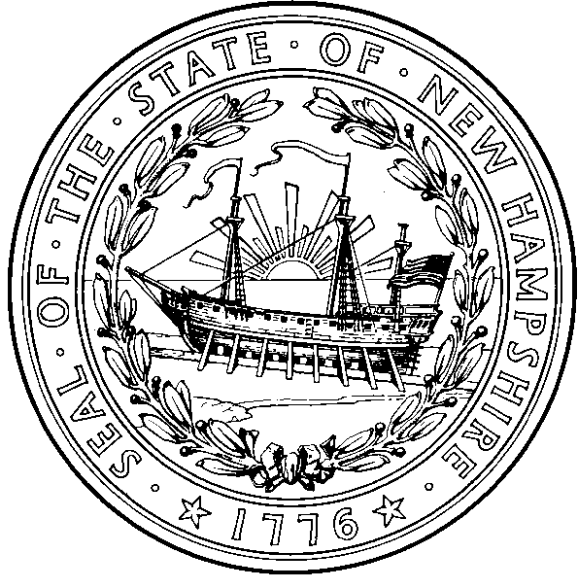  Nicholas A. Toumpas  Commissioner  Jose’ Thier Montero  Director | STATE OF NEW HAMPSHIRE  DEPARTMENT OF HEALTH AND HUMAN SERVICES  29 HAZEN DRIVE, CONCORD, NH 03301-6527  603-271-4482 1-800-852-3345 Ext. 4482  Fax: 603-271-3850 TDD Access: 1-800-735-2964 www.dhhs.nh.gov

New Hampshire

School Immunization Requirements 2012-2013

- Children must have proof of all required immunizations, or valid exemptions, in order to attend the first day of school. Documentation of immunity by confirming laboratory test results is acceptable.
- A child may be enrolled under conditional enrollment when the parent or guardian provides: (1) Documentation of at least one dose for each required vaccine; and (2) The appointment date for the next due dose of required vaccine. (He-P 300.13) http://www.gencourt.state.nh.us/rules/state_agencies/he-p300.html
- Look at the Minimum Age and Interval Table on page 2 for recommended minimum age and spacing information. All vaccine immunizations must meet minimum intervals and age requirements for that vaccine; a 4-day grace period is acceptable.
4. Medical and Religious Exemption information is available: http://www.dhhs.nh.gov/dphs/immunization/exemptions.htm
Varicella | K-3rd Grade  2 Doses1 | 4th Grade  2 Doses² | 5th Grade  1 Dose² | 6th –9th Grade  2 Doses² | 10th– 12thGrade  1 Dose²
DTaP  DT/DTP  Td/Tdap | 6 years and under: 4 or 5 doses, with the last dose given on or after the 4th birthday.  7 years and older: 3 or 4 doses, with the last dose given on or after the 4th birthday.  11 years and older: a one time dose Tdap when more than 5 years have passed since the last tetanus toxoid containing vaccine³ then boost with Td every 10 years. If a child turns 11 on or after the first day of school, they  are required to have Tdap prior to the first day of the next school year.
Polio | Kindergarteners: 3- 4 doses with one dose after age four and the last two doses separated by 6 months.  Grades 1-12: 3 doses, with the last dose given on or after the 4th birthday.4  Or 4 doses regardless of age at administration.4
MMR | Grades K-12: 2 doses required, at least one at or after 12 months of age
Hepatitis B | Grades K-12: 3 doses at acceptable intervals
January 2011 Page 1 of 2

New Hampshire School Immunization Requirements 2012/2013

Minimum Age & Interval for Valid Vaccine Doses
Vaccine | Dose # | Minimum Age | Minimum Interval Between Doses | Notes
Hepatitis B  HepB | HepB – Dose 1 | Birth | 4 weeks between Dose 1 & 2 | Minimum age for Dose 3 is >24 weeks.
Hepatitis B  HepB | HepB – Dose 2 | 4 weeks | 8 weeks between Dose 2 & 3 | Minimum age for Dose 3 is >24 weeks.
Hepatitis B  HepB | HepB – Dose 3 | 24 weeks | 16 weeks between Dose 1 & 3 | Minimum age for Dose 3 is >24 weeks.
Diphtheria, Tetanus, and Pertussis  DTaP/DT | DTaP – Dose 1 | 6 weeks | 4 weeks between Dose 1 & 2 | The fifth dose is not necessary if the fourth dose was administered at age 4 years or older.
Diphtheria, Tetanus, and Pertussis  DTaP/DT | DTaP – Dose 2 | 10 weeks | 4 weeks between Dose 2 & 3
Diphtheria, Tetanus, and Pertussis  DTaP/DT | DTaP – Dose 3 | 14 weeks | 6 months between Dose 3 & 4
Diphtheria, Tetanus, and Pertussis  DTaP/DT | DTaP – Dose 4 | 1 year | 6 months between Dose 4 & 5
Diphtheria, Tetanus, and Pertussis  DTaP/DT | DTaP – Dose 5 | 4 years | ------------------
Polio  IPV | IPV – Dose 1 | 6 weeks | 4 weeks between Dose 1 & 2 | If Dose 3 is given >4th birthday, only 3 doses are required (if an all OPV or all IPV schedule)  Incoming Kindergarteners: 3 - 4 doses, with one dose after age four years, and the last two doses separated by 6 months.
Polio  IPV | IPV – Dose 2 | 10 weeks | 4 weeks between Dose 2 & 3
Polio  IPV | IPV – Dose 3 | 14 weeks | 4 weeks to 6 months between  last 2 doses
Polio  IPV | ---------------------- | --------------------- | ---------------------
Measles, Mumps, and Rubella  MMR | MMR – Dose 1 | 12 months | 4 weeks between Dose 1 & 2 | If MMR, VAR, and nasal influenza vaccine are not given on the same day, they must be separated by at least 28 days.
Measles, Mumps, and Rubella  MMR | MMR – Dose 2 | 13 months | -----------------
Varicella (chickenpox)  VAR | VAR – Dose 1 | 12 months | 3 months between Dose 1 & 2 | If MMR, VAR, and nasal influenza vaccine are not given on the same day, they must be separated by at least 28 days.  If Dose 2 was given >28 days after Dose 1, it is valid.  If first dose administered ≥ age 13 years, two doses separated by a minimum interval of 4 weeks.
Varicella (chickenpox)  VAR | VAR – Dose 2 | 15 months | -------------------
Tetanus, Diphtheria, and Pertussis | Tdap –  A one time dose | 10 years | Tdap is a one-time dose only | If a child turns 11 on or after the first day of school, they are required to have a  one-time dose of Tdap vaccine prior to the first day of the next school year, except if the child has a medical contraindication to pertussis vaccine, in which case the child shall receive Tetanus diphtheria toxoid (Td) vaccine.

Immunization Requirements for Pre-school

Students 3-5 Years Old

Please refer to the Immunization Requirements School Year 2012/2013

for acceptable intervals and age requirements

DTaP (Diphtheria, Tetanus & Pertussis Vaccine)
3-5 years | Four doses - the third and fourth dose should be separated by at least 6 months.

POLIO
3-5 years | 3 doses – recommended at birth, 1-2 months, 6-18 months.  A fourth dose is usually given at 4-6 years.

MMR (Measles, Mumps & Rubella)
3-5 years | 1 or 2 doses- first dose recommended at 12-15 months.  A second dose is usually administered at 4-6 years.

HIB (Haemophilus Influenza type b)
3-5 years | One dose after 15 months of age or  Four dose series with the last dose being administered  at > 12 months of age.  HIB is not required for children > 5 years of age.

HEPATITIS B VACCINE
3-5 years | Three doses given at acceptable intervals.

VARICELLA (CHICKEN POX) VACCINE
3-5 years | One dose administered on or after age 12 months.  Documentation of immunity by confirming laboratory test results is required for incoming kindergarten students if child has not received varicella vaccine.

The 4-day grace period for minimum intervals and ages applies to the above requirements.

School Immunization Requirements, School Year 2012/2013
NH DHHS, Division of Public Health Services
NH Immunization Program

Page 3 of 4 February 2012

Brand Names for Vaccines

School nurses wanting to connect brand names to vaccine types may use the following list. The products that are crossed out are not provided through the New Hampshire Immunization Program. They are available in other states and countries.

Diphtheria, Tetanus, acellular Pertussis, (DTaP/ DT/DTP):
Infanrix®, Pediarix®, DT, Tetramune®, Daptacel®, Pentacel®

Diphtheria, Tetanus, acellular Pertussis and Polio (DTaP-IPV)
Kinrix

Tetanus diphtheria, acellular pertussis (Tdap)
Boostrix® (Manufacturer: GlaxoSmithKline. May 3, 2005: approved for persons 10 through 64 years of age)
Adacel® (Manufacturer: Sanofi Pasteur. June 10, 2005: approved for persons 11 through 64 years of age)

Haemophilus Influenzae Type B, (HIB):
ActHIB®, PedvaxHIB®, COMVAX®, Pentacel®, Hiberix®

Hepatitis B (HepB):
Engerix®, Pediarix®, Recombivax®, or COMVAX®

Measles, Mumps, Rubella, (MMR):
MMRII

Measles, Mumps, Rubella and Varicella
ProQuad®

Polio, (IPV/OPV):
IPOL or Pediarix®, Pentacel®

Varicella (Chicken Pox, VAR):
Varivax®

Page 4 of 4 February 2012

1 Varicella vaccination or laboratory diagnosis of chicken pox disease required. ² Varicella vaccination or history of chicken pox disease. 3 If the child has a medical contraindication to pertussis vaccine, the child shall receive Tetanus diphtheria toxoid (Td) vaccine. 4 If a combined IPV/OPV schedule was used, 4 doses are always required, even if the 3rd dose was administered after the 4th birthday. Page 1 of 4 February 2012

